Docker swarm ;

First we need to run this command,
Docker swarm init
Already exites that why display like this error,

Vim docker-compose.yaml
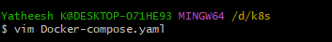

services:
ui-image:
image: yatheesh836/ems:ui-i
ports:
- "5000:5000"
networks:
- my_network

identity-image:
image: yatheesh836/ems:identity-i
ports:
- "5001:5001"
networks:
- my_network

employee-image:
image: yatheesh836/ems:e-i
ports:
- "5002:5002"
networks:
- my_network

networks:
my_network:
driver: overlay

~

Docker stack deploy -c docker-compose.yaml mystack-ems-application
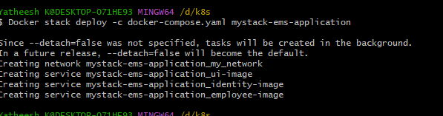
Check container running or not,
Docker container ls
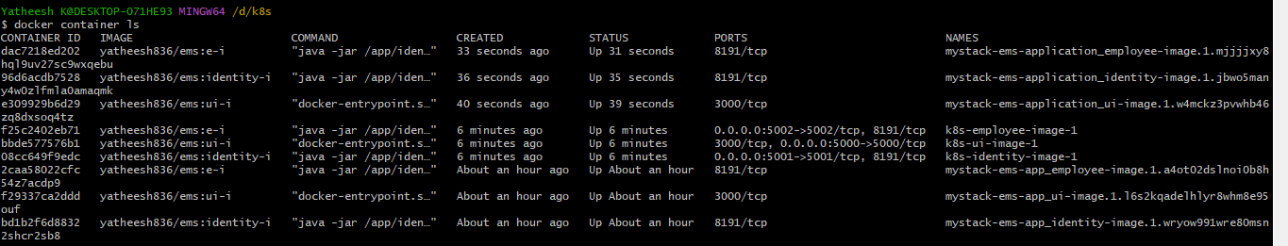

Remve one container,
Docker container rm -f [image-id]
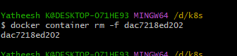

Check container,
We Remove one container,
Swarm created automaticly another container,
